**Stock Entry**

* Stock entry is done in sale point login(PACS, ARKS, DCMS etc.). User Name and password for sale point login is available at Dept.logins page (<http://ossds.telangana.gov.in/DeptLogins.aspx>).
* To enter the stock it is mandatory that Seed should be allotted to that sale point by MAO and freezed.
* If seed allotted and freezed than in dash board of sale point allotted details are displayed.

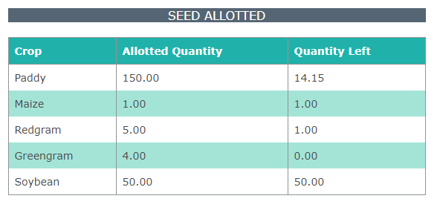

**Stock can be entered only when seed allotment details are displayed in dashboard**

To Enter Stock Details Click on Stock in menu and select Stock Entry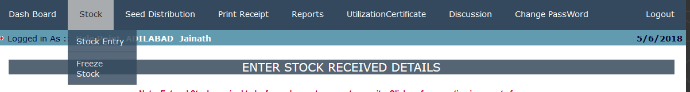

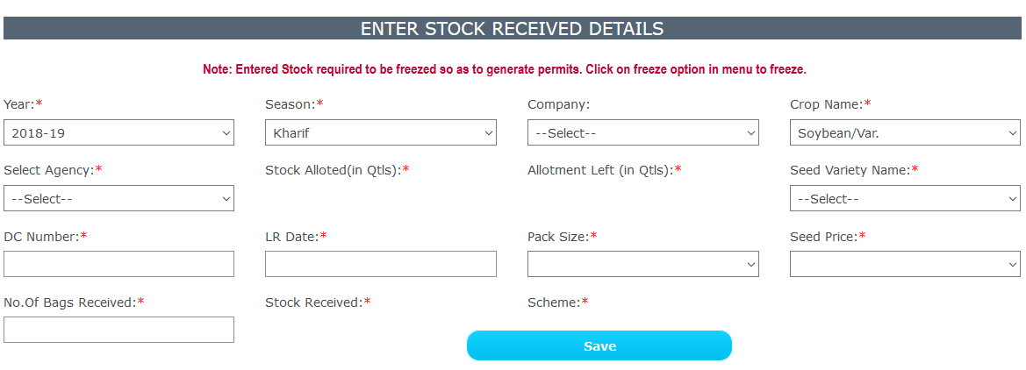

Select Year, season, select Company only for Hybrids (maize, jowar, bazra Etc..)Select crop, after crop selected agencies are displayed in drop down as per the allotment. Select agency

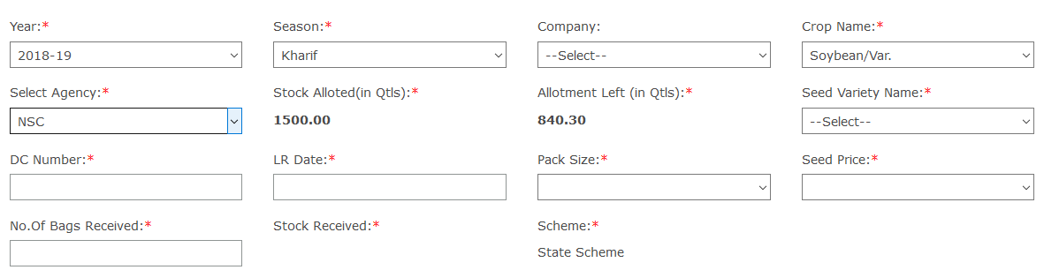

After agency selected, stock allotted and allotment left for the selected agency are displayed. Select crop variety, enter dc number, LR date, and select packing size and price. Once no. of bags entered system will calculate the stock received in quintals based on pack size. After stock received in quintals are displayed click on save. Details are saved.

If Pack Sizes or prices are not available for selected crop please inform to seed cell so that they can add details.

Once stock entered can be updated or deleted before freezing.

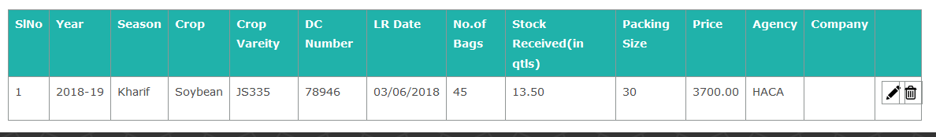

Update by clicking on , and delete by clicking on .

**After stock entered, so as to generate permit stock need to be freezed.**

To Freeze the stock entered click on Freeze in menu.

**Before freezing make sure that details** (price, pack size, no of bags, stock received in quintals, agency, DC number and LR date) **of stock entered is correct. After freezing stock details cannot be changed.** 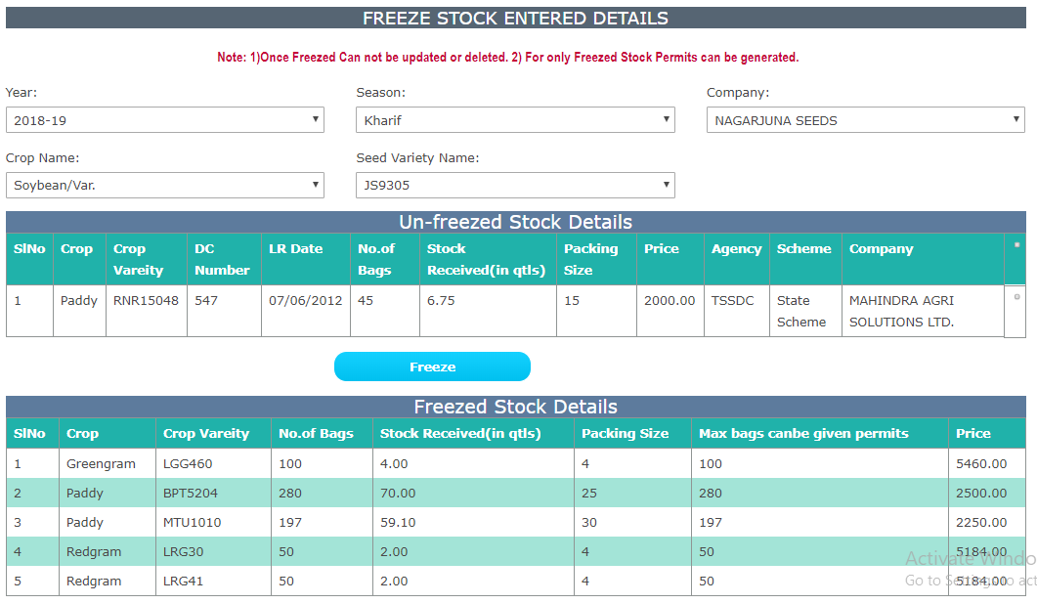

**Only for the freezed stock permit can be generated.**